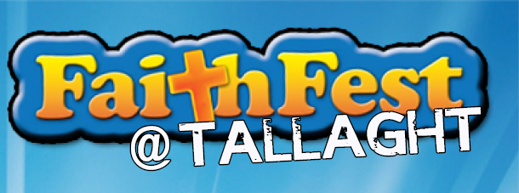

Parental Consent Form for FaithFest @ Tallaght  (Activity permission form for persons under 18 years)  Section A – The Organisation  Church organisation: Bishop Eamonn Walsh’s Area  Event: FaithFest @ Tallaght  Theme – MERCY MOVES MOUNTAINS  Venue: The Priory, Tallaght Village, Dublin 24.  Group: Youth [Teens] 12-18  Date: Friday 29th January 2016  Time: 6-9:30pm  Section B – Your Local Parish  Name of Parish: ___________________________  Name of Group Leader: ________________________  Contact Number: __________________________  Section C – The Young Person  Name of Young Person:  ____________________________________________  Address:  ____________________________________________  ____________________________________________  Telephone No:  _____________________________________  Date of Birth:  _____________________________________  Give details of any medical condition of which  ____________________________________________  ____________________________________________  ____________________________________________  ____________________________________________ | Section D – Consent to Participate  I have read all the information provided concerning the programme of the above activity. I hereby give permission for my son/daughter/ward to participate in the above activity.  The Archdiocese of Dublin only accepts liability or responsibility for an incident or accident caused by the negligence or breach of statutory duty of the organisation its servants or agents.  Signed: (Parent/Guardian):  _____________________________________  Date:  ____________________________  Address: (if different)  ____________________________________________  ____________________________________________  Contact telephone Number: (if different from above)  ____________________________________________  ______________________________  Please state the name and telephone numbers of available persons, during the period of the activity, in the event of non - availability of parent/guardian, in  the contact and telephone and address above.  Section E – Photo Release Permission  During the event, general photos may be taken.  Can we have permission to use these photos?  Please Circle YES / NO
  Name | Tel | Mobile

What is FaithFest @ Tallaght ?
It’s a fantastic initiative supported by Dublin Diocese and Scripture Union. Organised by Youth Focus group Faithfest @ Tallaght is an evening for young people packed with fun activities and workshops, celebrating faith and life!
A planning team – Youth Focus group is made up of people involved in youth ministry in the area of South Dublin, Tallaght and Blessington deaneries. We are delighted to invite you all to the next event:
FaithFest @ Tallaght is on Friday evening, January 29th, 2016 on theme –
MERCY MOVES MOUNTAINS
Testimony by
Br. Philip Mulryne - ex Manchester United and Nothern Ireland International footballer, studying to become a Dominican priest after leaving the glamour and fame behind.
Registration at 6 pm, opening – 6.30 pm. Event ends at 9.30 pm.
Workshops: Juniors 12-15
Anthea Parkes – 4th year performing arts student with Gaiety school of acting and Cois Ceim dance theatre – in this workshop you will be reflecting how to look after one another and love one another through movement and drama.

Church Without Walls are a group of people passionate about worship. Come and learn different styles, the reasons for worship and have oul jam with the band.
Seniors 15-18

Finbar Walsh - Live life foundation in the memory of Donal Walsh. He speaks to students about the importance of appreciating life and that there is always someone to talk to and that all our lives are valuable.
Daniel Ramamoorthy – ‘Why I couldn’t buy God?’ - entrepreneur, business consultant, and radio presenter. Big mansions, dinner with presidents and famous sportsmen, nice cars, great American colleges, diplomatic immunity… I literally had everything. But did I? Join this workshop if you want both money and God in your life.

If you have any queries visit us faithfestattallaght Or Email: faithfestattallaght@gmail.com

